

**PRODUCT SPECIFICATION**

|  |  |  |  |  |  |  |
| --- | --- | --- | --- | --- | --- | --- |
| GENERAL INFORMATION | | | | | | |
|  | | |  | | | | |
| Issued date: | | | 24-1-2022 |  |  | **Printed date:** | 08/07/2025 |
| Completed by | |  | | Quality Assurance Manager | | | |
|  | |  |  | | | |
| Product name | | | | **Pears dried, halves (medium choice) - 134000** | | | |
|  | |  |  | | | |
| Supplier | | | name | Outlet wholefood ltd | | | |
| address | Unit b2 canal bank, Hume avenue,  Park west industrial Park,  Dublin 12, D12PY02 | | | |
| phone no. | [+353 1 612 0462](tel:+35316120462) | | | |
| website | www.nutsinbulk.ie | | | |
| e-mail | sales@nutsinbulk.ie | | | |

|  |  |
| --- | --- |
| **Supplier Quality system** | We are BRC certified. |
|

|  |  |
| --- | --- |
| PRODUCT CHARACTERISTICS | |
|  | |  |
| **General** | | |
|  | |  |
| **Origin** | | South Africa |

|  |  |
| --- | --- |
| Description of the product | Dried pear, halves |

|  |  |  |  |  |
| --- | --- | --- | --- | --- |
| **List of ingredients**  in descending order by magnitude of weight.  *Also include additives and processing aids.* | components | % in the recipe | functionality* | country of origin |
| 1. Pears | 99.94 | raw material | South Africa |
| 1. SO2 ( E 220 ) | 0.06 | preservative |  |
|  |  |  |  |
|  |  |  |  |

|  |
| --- |
| **Analytical / Organoleptical values** |

|  |  |
| --- | --- |
| Organoleptic |  |
| Appearance | Fairly regular halves, free from visible discolouration, insects and fermentation. |
| Colour | Bright and uniform colour typical of the cultivar |
| Flavour | Characteristic for dried pears, free from off flavour |
| Odour | Characteristic for dried pears, free from off odour |
| Texture | Chewy, not hard |

|  |  |  |
| --- | --- | --- |
| Analytical | | Maximum |
| SO2 | | 600 ppm |
| mycotoxins: | * aflatoxin B1 | 2 ppb |
|  | * aflatoxin tot. | 4 ppb |

|  |  |
| --- | --- |
| Microbiological | Maximum |
| Escherichia coli | <10 |
| Salmonella | Absent/25g |

|  |  |
| --- | --- |
| Physical (per 100g) | Choice grade |
| **Colour deviation** |  |
| Minor | 10 |
| Major | 1 |
| **Blemishes** |  |
| Minor | 20 |
| Major | 5 |
| **Damaged** | 2 |
| **Crystallised fruit** | 3 |
| **Size group** |  |
| Too large | 5 |
| Too small | 5 |
| Foreign material | 0.01% |
| Extraneous matter | 0.1% |
| Size medium | min 27.5mm – max 38 mm |
| Count per kg | Target 90 |

|  |  |
| --- | --- |
| **Packaging** | Carton box with inner PE bag |
| weight per colli | 12,5 kg/15 kg |

|  |  |
| --- | --- |
| **Physical form** (e.g. powder, liquid) | Pieces (halves) |
| shelf life | 12 months from production date under mentioned conditions in closed packaging |
| storage conditions | Cool, dry and out of direct sunlight. Temp. < 15°C RH < 70% |
|  |  |

|  |
| --- |
| **GMO & Novell Foods** |

|  |  |  |  |
| --- | --- | --- | --- |
| Does the product or components hereof, contain **GM micro-organisms or is it produced with GM micro-organisms** (incl. processing aids and additives) | ☑ | no |  |
| □ | yes | specifically: |

|  |
| --- |
| HEALTH ISSUES |

|  |
| --- |
| **Nutritional information** |

□ Not available

☑ Available

|  |  |  |
| --- | --- | --- |
| 1.1 | Wheat | - |
| 1.2 | Rye | - |
| 1.3 | Barley | - |
| 1.4 | Oats | - |
| 1.5 | Spelt | - |
| 1.6 | Kamut | - |
| 1.7 | Gluten | - |
| 2.0 | Crustaceans | - |
| 3.0 | Egg | - |
| 4.0 | Fish | - |
| 5.0 | Groundnuts | - |
| 6.0 | Soya | - |
| 7.0 | Milk | - |
| 8.1 | Almonds | - |
| 8.2 | Hazelnuts | - |
| 8.3 | Walnuts | - |
| 8.4 | Cashewnuts | - |
| 8.5 | Pecans | - |
| 8.6 | Brazilnuts | - |
| 8.7 | Pistachios | - |
| 8.8 | Macadamia nuts | - |
| 8.9 | Nuts | - |
| 9.0 | Celery | - |
| 10.0 | Mustard | - |
| 11.0 | Sesame | - |
| 12.0 | Sulphur dioxide (E220-E228) | w |
| 13.0 | Lupine | - |
| 14.0 | Molluscs | - |

|  |  |  |  |  |
| --- | --- | --- | --- | --- |
| per | □ | 100 ml | ☑ | 100 g |

|  |  |  |
| --- | --- | --- |
| Energy | 1163 | kJ |
|  | 275 | kcal |
|  |  |  |
| Proteins | 1.1 | g |
| * % vegetable |  |  |
| source |  |  |
| * % animal | - |  |
| source | - |  |
|  |  |  |
| Carbohydrates | 59.5 | g |
| * sugars | 59.5 | g |
| * starch | - | g |
| * polyols | - | g |
|  |  |  |
| Dietary Fibre | 12.6 | g |
|  |  |  |
| Total content of fat | 0.5 | g |
| * % vegetable |  |  |
| * % animal | - |  |
| * saturated fatty acids | 0.1 | g |
| * mono-unsaturated fatty acids | 0 | g |
| * poly-unsaturated fatty acids | 0 | g |
| * cholesterol |  | mg |
| * trans-fatty acids | - | mg |
|  |  |  |
| Calcium (Ca) |  | mg |
| Iron (Fe) |  | mg |
| Magnesium (Mg) |  | mg |
| Phosphorus (P) |  | mg |
| Sodium (Na) | 4 | mg |
| Potassium (K) |  | mg |
| Zinc (Zn) |  | mg |
| Copper (Cu) |  | mg |
| Maganese (Mn) |  | mg |
| Selenium (Se) |  | mcg |
| Sodium chloride (NaCl-salt) | - | mg |

|  |
| --- |
| **Allergen information** |

*Please indicate presence or absence of listed allergens*

W: Recipe with C: Can contain

-: Recipe withoucross contamination

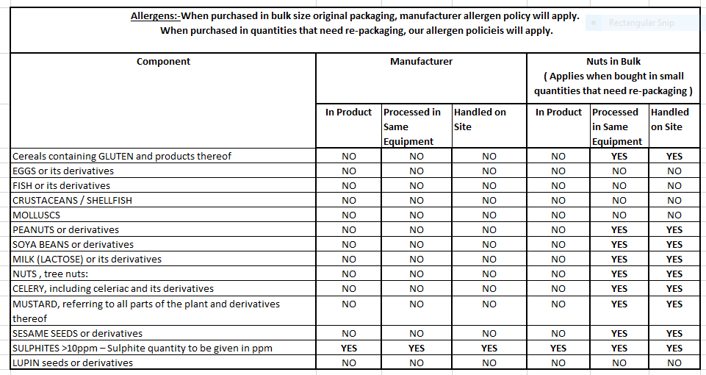

|  |
| --- |
| **Remarks** |

**Use in production**

If the goods or any part thereof supplied under the contract are processed, altered or tampered with in any way by the buyer or receiver of the goods or any other person, the quality of the goods shall be deemed to be acceptable to the buyer. All customer’s quality control checks are to be completed on the entire load, prior to production and us.